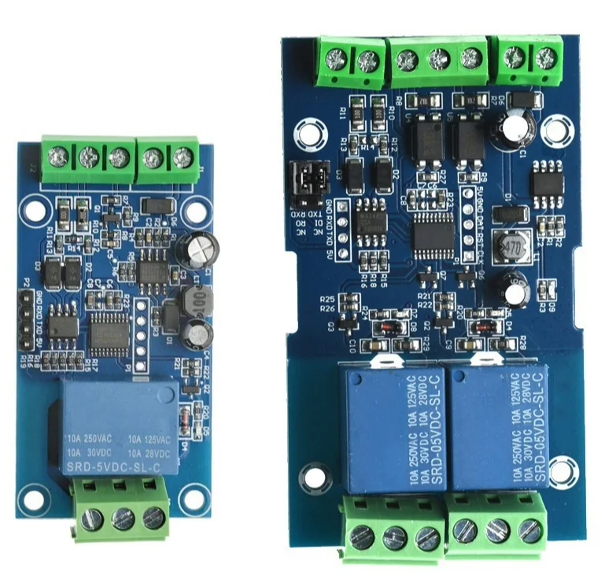

**Instruction brief**

Modbus devices perform relevant operations by receiving ModbusRTU instructions from external control terminals (such as upper computer /MCU).

A frame instruction is generally composed of device address, function code, register address, register data, check code, and frame length is related to the function code. Generally, the first byte of each frame data is the device address, which can be set to 1-255. The default is 255(0xFF), and the last two bytes are the CRC check code.

Assuming the device address is 255, the commonly used ModbusRTU command is as follows:

**1,** Turn on relay 1 (manual mode)                                                             **2,** Turn off relay 1 (manual mode)

Send :FF 05 00 00 FF 00 99 E4                                                                   Send :FF 05 00 00 00 00 D8 14

Return as is :FF 05 00 00 FF 0099 E4                                                        Return as is :FF 05 0000 0000 D814

Note :1. The third to fourth bytes of the send frame represent

Relay address, address of relay 1-- Relay 8

X0002 respectively x0000 0, 0 x0001, 0, 0 x0003

X0005 0 x0004, 0, 0 x0006, 0 x0007

2. The 5th -- 6th byte of the send frame represents the data.

0xFF00 means turn on the relay, 0x0000 means

Turn-off relay

**3,** Turn on relay No. 2 (manual mode)  **4,** Turn off relay No. 2 (manual mode)

Send: FF 05 00 01 FF 00 C8 24  Send :FF 05 00 01 00 00 89 D4

The original value is returned :FF 05 00 01 FF 00 C8 24  The original value is FF 05 00 01 00 00 89 D4

**5,**Turn on all relays                                                                                         **6,** Turn off all relays

 Send :FF 0F 00 00 00 08 01FF 30 1D                                                             Send :FF 0F 00 00 00 08 0100 705D

 Back :FF 0F 00 00 00 08 41 D3                                                                      Back to :FF 0F 00 00 00 08 41D3

**7,** set device address to 1 **8,** set device address to 255

 Send :00 10 00 00 000102 00016A 00                                                             Send :00 10 00 00 000102 00 FF EB 80

 Return :00 10 00 00 00 01 02 01 6A 00                                                           Return :00 10 00 00 00 01 02 00 FF EB 80

 Note: The ninth byte 0x01 of the sent frame is written                                    Note: The ninth byte 0xFF of the sent frame is written

          Device address                                                                                                   Device address

**9,** Read the device address

Send :00 03 00 00 00 01 85 DB

Return: 00 03 02 00 FF C5 C4

Note: The fifth byte 0xFF of the returned frame is read

To the device address

**10,** read the relay status

Send: FF 0100 00 00 08 28 12

Return: FF010101A1A0

Note: The Bit0--Bit of the fourth byte 0x01 of the frame is returned

7 represents relay 1-- relay 8,0 is off,

1 for open

**11,** Read the optocoupler input status

Send :FF 02 00 00 00 08 6C 12

Return :FF 02 01 01 51 A0

Note: IN1 of the fourth byte 0x01 of the frame is returned

--IN8 represents the input signals of optocoupler 1 and optocoupler 8 respectively

0 indicates low level and 1 indicates high level

**12,** Set the baud rate to 4800

Send :FF 10 03 E9 00 01 02 00 02 4A 0C

Back to :FF 10 03 E9 00 01 C5 A7

Note: The 9th byte of the sent frame is the baud rate setting value.

0x02,0x03, and x04 represent 4800,9600,19200, respectively

**13,** set the baud rate to 9600

Send :FF 10 03 E9 00 01 02 00 03

8BCC

Back to :FF 10 03 E9 00 01 C5 A7

**14,** set the baud rate to 19200

Send :FF 10 03 E9 00 01 02 00 04

CA 0E

Back to :FF 10 03 E9 00 01 C5 A7

**15,** read baud rate

Send :FF 03 03 E8 00 01 11 A4

Back to :FF 03 02 00 04 90 53

Note: The fifth byte of the returned frame indicates that it was read

The baud rate of 0x02,0x03, and x04 respectively represent

4,800, 9,600, 19,200

**16,** Turn on relay 1 (flash closed mode 2S)

Send: FF 10 00 03 00 02 04 00 04 00 14 C5 9F

Back to :FF 10 00 03 00 02 A4 16

Note :(1) The third to fourth byte of the transmit frame represents relay

The addresses of relay 1 and relay 8 are respectively

X000d x0003 0, 0 x0008, 0, 0 x0012, 0 x0017

0 x001c, 0 x0021. 0 x0026

(2) The 10th - 11th byte of the send frame represents the delay setting value,

The delay base is 0.1s, so the delay time is 0x0014*0.1=

20*0.1S=2S, the relay will turn off automatically after 2S

**17,** turn off relay No. 1 (flash break mode 3S)

Send :FF 10 00 03 00 02 04 00 02

00 1E A5 99

Back to :FF 10 00 03 00 02 A4 16

Note:

(1) Send the third - fourth byte of the frame

Represents relay address, relay 1-- relay 8

The addresses are 0x0003,0x0008,0x000D,

X001c x0012 0, 0 x0017, 0, 0 x0021,

0x0026

(2) The 10th - 11th byte of the send frame represents

Delay Set value. The delay base is 0.1S, so the delay is delayed

The time is 0x001E*0.1=30* 0.1s =3S

The appliance turns on automatically after 3S

**18,** Disable/enable the optocoupler input control relay function

Disable sending :00 FO 0035CO

The original value is 00F00035CO

Enable sending :00FO01F400

The original value is 00 FO01F400

Note :1, disabled by default, can be sent to the serial port assistant

This command enables or disables the function and supports power failure saving.

2, Point 18 Only products after 2021-12 have this

Features!

Modbus RTU Command:  
1>.Suppose the device address is 0xFF so return 00 10 00 00 00 01 02 00 FF EB 80 and the 9th btye is device address.  
2>.Turn ON CH_1 Relay(Normal Mode):  
Send: FF 05 00 00 FF 00 99 E4  
Return: FF 05 00 00 FF 00 99 E4  
Note_1:The 3rd and 4th byte are relay addresses.So it can be 0x0000,0x0001,0x0002,0x0003.  
Note_2:The 5th and 6th byte are relay data.0xFF00 means turn ON relay and 0x0000 means turn OFF relay.  
3>.Turn OFF CH_1 Relay(Normal Mode):  
Send: FF 05 00 00 00 00 D8 14  
Return: FF 05 00 00 00 00 D8 14  
4>.Turn ON CH_2 Relay(Normal Mode):  
Send: FF 05 00 01 FF 00 C8 24  
Return: FF 05 00 01 FF 00 C8 24  
5>.Turn OFF CH_2 Relay(Normal Mode):  
Send: FF 05 00 01 00 00 89 D4  
Return: FF 05 00 01 00 00 89 D4  
6>.Turn ON All relays:  
Send: FF 0F 00 00 00 08 01 FF 30 1D  
Return: FF 0F 00 00 00 08 41 D3  
7>.Turn OFF All relays:  
Send: FF 0F 00 00 00 08 01 00 70 5D  
Return: FF 0F 00 00 00 08 41 D3  
8>.Set device address to 0x01:  
Send: 00 10 00 00 00 01 02 00 01 6A 00  
Return: 00 10 00 00 00 01 02 00 01 6A 00  
Note: The 9th btye is device address.  
9>.Set device address to 0xFF:  
Send: 00 10 00 00 00 01 02 00 FF EB 80  
Return: 00 10 00 00 00 01 02 00 FF EB 80  
10>.Read device address:  
Send: 00 03 00 00 00 01 85 DB  
Return: 00 03 02 00 FF C5 C4  
Note: The 5th btye is device address.  
11>.Read relay status:  
Send: FF 01 00 00 00 08 28 12  
Return: FF 01 01 01 A1 A0  
Note:The 4th means which one relay.0 means OFF and 1 means ON.  
12>.Read optocoupler input staturs:  
Send: FF 02 00 00 00 08 6C 12  
Return: FF 02 01 01 51 A0  
Note:The 4th means which one input.0 means low level signal input and 1 means high level signal input.  
13>.Set baud rate 4800bps:  
Send: FF 10 03 E9 00 01 02 00 02 4A 0C  
Return: FF 10 03 E9 00 01 C5 A7  
Note:The 9th btye is baud rate value.0x02 is 4800bps.0x03 is 9600bps.0x04 is 19200bps.  
14>.Set baud rate 9600bps:  
Send: FF 10 03 E9 00 01 02 00 03 8B CC  
Return: FF 10 03 E9 00 01 C5 A7  
15>.Set baud rate 19200bps:  
Send: FF 10 03 E9 00 01 02 00 04 CA 0E  
Return: FF 10 03 E9 00 01 C5 A7  
16>.Turn ON CH_1 Relay(2S Flashing Mode):  
Send: FF 10 00 03 00 02 04 00 04 00 14 C5 9F  
Return: FF 10 00 03 00 02 A4 16  
Note_1:The 3rd and 4th byte are relay addresses.So CH1~CH4 can be 0x0003,0x0008,0x000D,0x0012.  
Note_2:The 10th and 11th byte are delay time in second.The minimum delay time is 0.1s.Relay will OFF after delay time.So the delay time in this command is : 0x0014*0.1=2S.  
17>.Turn OFF CH_1 Relay(3S Flashing Mode):  
Send: FF 10 00 03 00 02 04 00 02 00 1E A5 99  
Return: FF 10 00 03 00 02 A4 16  
Note:Relay will ON after delay time.So the delay time in this command is : 0x001E*0.1=3S.